BHARATI VIDYAPEETH (DEEMED TO BE UNIVERSITY),
COLLEGE OF ENGINEERING,
PUNE-411043

Department of Information Technology

A
Project Based Learning
Microcontrollers and Microprocessors
On
“ TriSense: A Gesture, Voice and Face-Based Contactless PC Control System with Arduino Feedback”
Submitted By
Roll No. | PRN No. | Name
21 | 2514110443 | Amit Gadade
28 | 2514110450 | Kumar Pratyush
31 | 2514110453 | Basavaraj Kammar
33 | 2514110455 | Shravan Chandore
22 | 2514110444 | Piyush Kapile
Under the Guidance of
Prof. Prakash Devale
DEPARTMENT OF INFORMATION TECHNOLOGY
Certificate
This is to certify that the work under Project Based Learning (PBL) for the topic “TriSense: A Gesture, Voice and Face-Based Contactless PC Control System with Arduino Feedback” is carried out by “Amit Gadade, Kumar Pratyush, Basavaraj Kammar, Shravan Chandore & Piyush Kapile” under the guidance of Prof. Prakash Devale in partial fulfillment of the requirement for the degree of “Bachelor of Technology in Information Technology Semester-III” of “Bharati Vidyapeeth (Deemed to be University), Pune” during the academic year 2023-2024.

Date:- Prof. Prakash Devale

GUIDE
ACKNOWLEDGEMENT

We would like to express deepest appreciation towards Dr Vidula Sohoni, Principal, Bharati Vidyapeeth (Deemed to Be University) College of Engineering, Pune, India and Dr.Sandeep Vanjale Head of the Department (IT), who invaluable supported us in completing this project.
We are profoundly grateful to Prof. Prakash Devale, Project guide for her expert guidance and continuous encouragement throughout to see that this project rights, its target since its commencement to its completion.
At last we must express our sincere heartfelt gratitude to all the staff members of IT Department who helped us directly or indirectly during this course of work.

Amit Gadade
Kumar Pratyush
Basavaraj Kammar
Shravan Chandore
Piyush Kapile
B.Tech. (IT) Semester – III

INDEX

Sr. No. | Title | Page No.
1. | Introduction | 5
2. | Circuit Diagram | 8
3. | Components & Software Used | 10
4. | Applications | 13
5. | Execution Steps | 14
6. | Model Images | 19
7. | Conclusion | 20

1. INTRODUCTION

1.1 Background
The keyboard and mouse have been the main way of controlling a computer for decades. They work well, but they need physical contact and a free pair of hands. In many everyday situations this is inconvenient: a presenter standing away from the laptop, a person cooking with a recipe open on the screen, a technician with dirty or gloved hands, or a user with limited hand mobility.
Recent progress in computer vision and speech recognition now allows hand tracking, face tracking and offline voice recognition to run in real time on an ordinary laptop. At the same time, microcontrollers such as the Arduino make it easy to build small physical interfaces made of buttons, lights and displays.
This Project Based Learning (PBL) work, carried out for the course Microcontrollers and Microprocessors, combines both ideas. TriSense is a contactless PC control system that accepts three kinds of input (hand gestures, voice commands and face/head movement) and uses an Arduino Uno as a physical control panel that selects the active mode and gives clear visual feedback.

1.2 Problem Statement
Controlling a PC normally requires touching the keyboard, mouse or touchpad. Existing gesture or voice tools are usually software-only: the user gets no physical indication of which input mode is active, or whether a command was actually recognised. This makes such tools feel unreliable. There is a need for a low-cost contactless control system that supports more than one input method and also provides immediate, visible hardware feedback.

1.3 Objectives
- To control a PC without touching it, using hand gestures, voice commands and face/head movement.
- To perform common actions such as volume control, mute, play/pause, next/previous track, scrolling, zoom, opening applications, taking a screenshot, locking the PC and clicking.
- To build an Arduino Uno control panel with a mode button, four indicator LEDs and a 16x2 I2C LCD.
- To define one simple serial message format (the message contract) so that modules written by different team members work together without changes.
- To provide a Flask web dashboard showing a live command log and mode toggles.
- To keep the system low cost, solder-free (breadboard only) and able to work offline.

1.4 Scope and Limitations
- The software runs on a Windows laptop with a built-in or USB webcam and microphone.
- The system supports a fixed set of 15 commands (listed in Section 3.5).
- Voice recognition is offline, so no internet connection is needed for it.
- The Arduino connects over a single USB serial link at 9600 baud.
- Accuracy depends on lighting (for gestures and face tracking) and on background noise (for voice).
- Cursor movement by head tracking is handled inside Python and is not sent to the Arduino, because it would produce too many messages.

1.5 System Overview
TriSense has two cooperating parts. The laptop does all the heavy work: it captures camera and microphone input, recognises gestures, voice commands and face movements, and performs the actual PC actions. The Arduino Uno is a small physical control panel. Data flows in both directions over USB: Python sends status messages to the Arduino, and the Arduino sends back button presses.
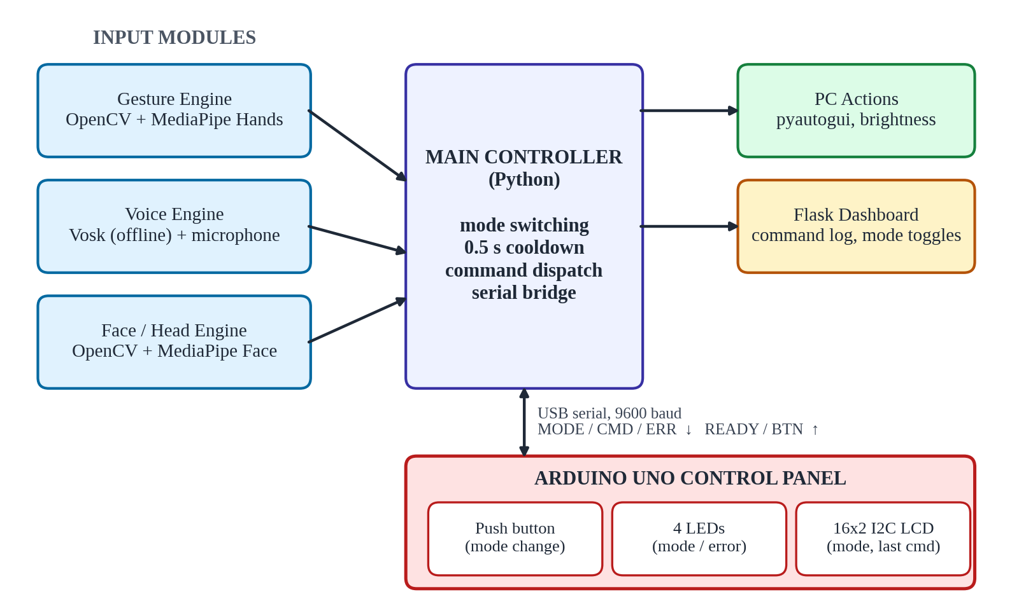
Figure 1.1: Block diagram of the TriSense system
The working of the system can be summarised in the following steps:
- One of the three input modules (gesture, voice or face) detects an event and prints it in the standard form [SOURCE] COMMAND, for example [GESTURE] VOLUP.
- The main controller checks that the 0.5 second cooldown for that command has passed.
- The controller performs the PC action using pyautogui (or screen-brightness-control for brightness).
- The controller sends CMD:<name> to the Arduino, which shows the command on the LCD, and records it in the dashboard log.
- When the user presses the button, the Arduino sends BTN:PRESSED; the controller then switches to the next mode and sends MODE:<name> so that the LEDs and LCD are updated.

1.6 Operating Modes
The system works in one of three modes at a time. The push button on the Arduino panel cycles through them in the order Gesture, Voice, Face and back to Gesture.
Table 1.1: Operating modes of TriSense
Mode | Input used | LED | Typical commands
GESTURE | Webcam, hand gestures (MediaPipe Hands) | Blue (D8) | VOLUP, VOLDOWN, SCROLLUP, ZOOMIN
VOICE | Microphone, spoken phrases (Vosk) | Green (D9) | OPEN_CHROME, SCREENSHOT, LOCK
FACE | Webcam, head movement and blinks | Yellow (D10) | CLICK, LOCK
ERROR | Camera or microphone not available | Red (D11) | ERR:NO_CAM, ERR:NO_MIC

1.7 Work Division
To let team members work in parallel, the project was split into independent modules. Only the Arduino part needs the hardware; the other modules are developed on the laptop alone and simply print what they detect.
Table 1.2: Module-wise work division
Module | Responsibility | Needs Arduino?
Gesture engine | Hand detection with MediaPipe, mapping of hand poses to commands | No
Voice engine | Offline speech recognition with Vosk, mapping of phrases to commands | No
Face / head tracking | Head-controlled cursor, blink click | No
Arduino firmware, serial bridge and Flask dashboard | LEDs, button, LCD, serial message handling, command log and mode toggles | Yes
Main controller | Combines all modules, performs PC actions, handles mode switching | Yes (final stage)

2. CIRCUIT DIAGRAM

2.1 Circuit Overview
The hardware is built on a solderless 830-point breadboard around an Arduino Uno compatible board (CH340 USB chip). The board is powered through the same USB cable that carries the serial data to the laptop, so no external power supply is needed. Four LEDs, one push button and a 16x2 I2C LCD are connected to the Arduino as shown in Figure 2.1.
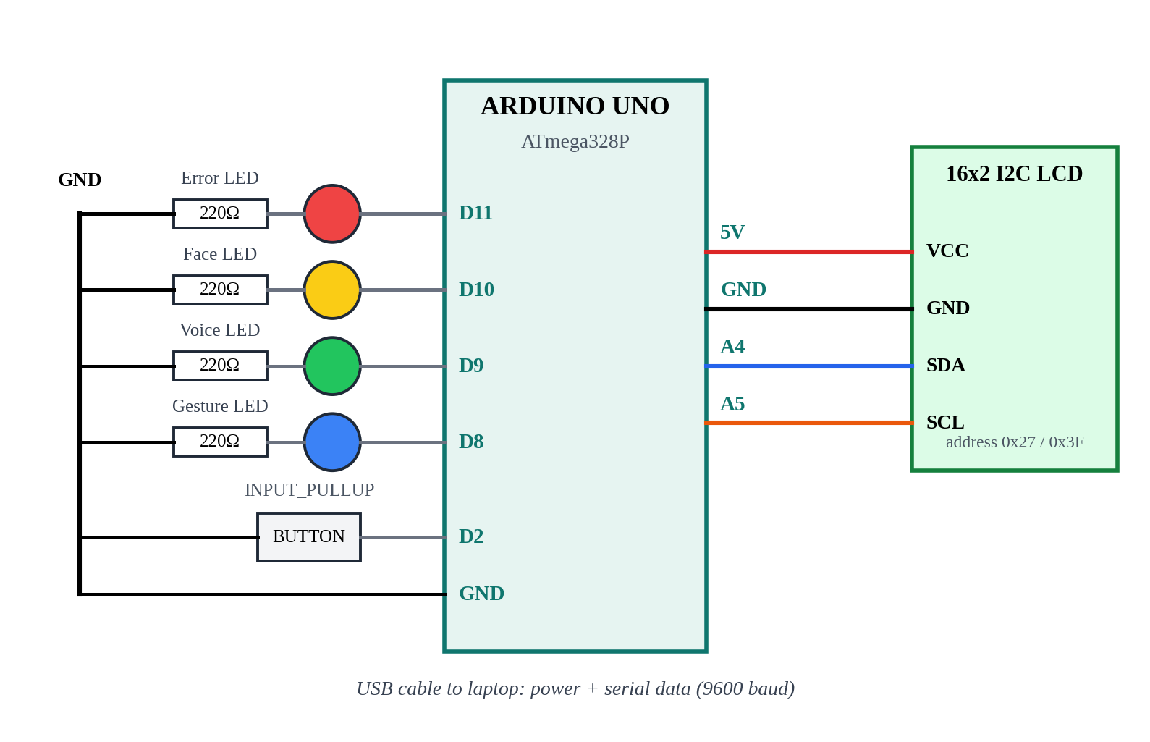
Figure 2.1: Circuit diagram of the Arduino control panel

2.2 Pin Connections
Table 2.1: Arduino pin connections
Component | Component pin | Arduino pin | Remarks
16x2 I2C LCD | GND | GND | Common ground
16x2 I2C LCD | VCC | 5V | Power supply
16x2 I2C LCD | SDA | A4 | I2C data line
16x2 I2C LCD | SCL | A5 | I2C clock line
Blue LED | Anode (+) | D8 | Gesture mode; 220 Ω to GND
Green LED | Anode (+) | D9 | Voice mode; 220 Ω to GND
Yellow LED | Anode (+) | D10 | Face mode; 220 Ω to GND
Red LED | Anode (+) | D11 | Error; 220 Ω to GND
Push button | One leg | D2 | Other leg to GND
Push button | Other leg | GND | Used with INPUT_PULLUP

2.3 Working of the Circuit
LEDs. Each LED is connected in series with a 220 Ω resistor between its Arduino pin and GND. With a 5 V output, the current is roughly 9 to 14 mA depending on the LED colour, which is below the 20 mA recommended per pin. Without the resistor the LED and the pin could be damaged.
Push button. The button joins pin D2 to GND. The pin is configured as INPUT_PULLUP, which enables the internal pull-up resistor of the ATmega328P. The pin therefore reads HIGH when the button is released and LOW when it is pressed, and no external resistor is needed. Mechanical contacts bounce for a few milliseconds, so the firmware ignores changes that occur within 50 ms of the previous one (debouncing).
I2C LCD. The LCD has a small I2C backpack (PCF8574) that reduces the connections to just four wires. On the Arduino Uno, A4 is the hardware SDA line and A5 is the hardware SCL line. The module normally answers at I2C address 0x27; some modules use 0x3F. If the screen stays blank, the other address should be tried, and the contrast potentiometer on the backpack adjusted.
USB serial link. The USB cable connects the Arduino to the laptop. The CH340 chip converts USB to serial, and the laptop sees the board as a COM port (for example COM6). Messages are exchanged at 9600 baud as plain text lines.

2.4 Breadboard Wiring Tips
- Unplug the USB cable while changing wires, and check every connection before powering on.
- The longer leg of an LED is the anode (+) and goes towards the Arduino pin; the shorter leg goes through the resistor to GND.
- Breadboard holes are connected in rows of five; the long side rails are used for GND.
- Use male-to-female jumper wires to connect the LCD pins to the breadboard and Arduino.
- Add and test one component at a time: LEDs first, then the button, then the LCD.

3. COMPONENTS & SOFTWARE USED

3.1 Hardware Components
Table 3.1: Hardware components
Sr. | Component | Specification | Qty | Purpose
1 | Laptop | Windows, webcam, microphone, USB port | 1 | Runs Python and all processing
2 | Arduino Uno (clone) | ATmega328P, 5 V, CH340 USB chip | 1 | Physical control panel
3 | 16x2 I2C LCD | HD44780 with PCF8574 backpack | 1 | Shows mode and last command
4 | LEDs | Blue, green, yellow, red | 4 | Mode and error indication
5 | Resistors | 220 Ω | 4 | Current limiting for LEDs
6 | Push button | Tactile switch | 1 | Mode change
7 | Breadboard | 830 tie-points | 1 | Solder-free circuit
8 | Jumper wires | Male-male and male-female | 1 set | Connections
9 | USB cable | USB-A to USB-B | 1 | Power and serial data

3.2 Hardware Description
Arduino Uno. The Arduino Uno is a development board based on the ATmega328P 8-bit microcontroller. It runs at 16 MHz from a 5 V supply and has 32 KB of flash memory, 2 KB of SRAM, 1 KB of EEPROM, 14 digital input/output pins and 6 analog inputs. In this project it reads the button (digital input), drives the LEDs (digital outputs), talks to the LCD over I2C and communicates with the laptop over UART serial. Clone boards use a CH340 chip instead of the ATmega16U2 for USB; Windows normally installs its driver automatically.
16x2 I2C LCD. A character display with two lines of sixteen characters. The I2C backpack lets it be driven with only SDA and SCL. Line 1 shows the mode (MODE: VOICE) and line 2 shows the last command (Last: VOLUP).
LEDs and resistors. Four LEDs give instant visual feedback: blue for gesture mode, green for voice mode, yellow for face mode and red for errors. Each has a 220 Ω current limiting resistor.
Push button. A single tactile switch used to cycle through the three modes without touching the PC.

3.3 Software and Libraries
Table 3.2: Software and libraries
Software / library | Used for
Python 3 (Windows) | Main programming language for all PC-side modules
OpenCV | Camera capture and image handling
MediaPipe | Hand landmark detection (gestures) and face landmark detection (head tracking, blink)
Vosk | Offline speech recognition
pyautogui | Keyboard, mouse and scroll actions: volume, scroll, screenshot, click
screen-brightness-control | Changing the screen brightness
Flask | Web dashboard with live command log and mode toggles
pyserial | Serial communication between Python and the Arduino
Arduino IDE 2.3.10 | Writing and uploading the Arduino firmware
LiquidCrystal_I2C | Arduino library for the I2C LCD
GitHub / shared folder | Sharing code between team members

3.4 Serial Message Contract
All modules follow one strict message format. It was agreed before development started so that every module could be built and tested independently. The format must not be changed without informing the whole team.
Table 3.3: Serial settings and message format
Item | Rule
Baud rate | 9600
Encoding | Plain text; every message ends with a newline (\n)
Format | TYPE:VALUE
Characters | ALL CAPS, no spaces (use _ instead)
Value length | Maximum 12 characters
Port access | Only one program can use the COM port at a time; close the Arduino Serial Monitor before running Python

Table 3.4: Messages exchanged
Direction | Message | Meaning
Python → Arduino | MODE:GESTURE | Gesture mode active (blue LED)
Python → Arduino | MODE:VOICE | Voice mode active (green LED)
Python → Arduino | MODE:FACE | Face mode active (yellow LED)
Python → Arduino | CMD:<name> | A command was executed; shown on LCD line 2
Python → Arduino | ERR:<reason> | Something failed (e.g. ERR:NO_MIC, ERR:NO_CAM); red LED and LCD
Arduino → Python | READY | Arduino has just started; Python replies with MODE:GESTURE
Arduino → Python | BTN:PRESSED | Button pressed; Python switches to the next mode

To avoid overloading the serial link, three rules are followed: (1) only events are sent, never a constant stream; (2) each command has a cooldown of about 0.5 s so that one gesture does not fire many times; (3) at most about 10 messages per second are sent to the Arduino.

3.5 Command Set
Table 3.5: Official command names and the PC action performed
Group | Command | PC action
Shared | VOLUP / VOLDOWN | Increase / decrease system volume
Shared | MUTE | Mute or unmute
Shared | PLAYPAUSE | Play or pause media
Shared | NEXT / PREV | Next / previous track
Gesture | SCROLLUP / SCROLLDOWN | Scroll the active window
Gesture | ZOOMIN / ZOOMOUT | Zoom in / out
Voice | OPEN_CHROME | Open the Chrome browser
Voice | OPEN_NOTEPAD | Open Notepad
Voice | SCREENSHOT | Capture the screen
Voice, Face | LOCK | Lock the PC
Face | CLICK | Mouse left-click (blink)

3.6 Software Modules
Gesture engine. OpenCV reads frames from the webcam and MediaPipe Hands returns 21 landmarks for each detected hand. The program checks which fingers are raised and maps each hand pose to a command, for example an open palm for VOLUP. A cooldown prevents repeated firing while the pose is held.
Voice engine. The microphone audio is passed to a Vosk offline model. The recognised text is matched against a small list of phrases such as “open chrome” or “screenshot”, and the matching command name is produced.
Face / head tracking. MediaPipe face landmarks are used to follow the head. The position of the nose moves the mouse cursor, and a blink (detected from the eye landmarks) produces the CLICK command. Only the click is reported as a command; cursor movement stays inside Python.
Main controller and dashboard. The controller imports the three modules, receives their events, performs the PC action, talks to the Arduino through pyserial and keeps track of the current mode. A Flask dashboard shows the live command log and lets the user switch modes from a browser.

4. APPLICATIONS

4.1 Assistive technology
People with limited hand mobility can control volume, media and applications using voice or head movement instead of a keyboard and mouse.

4.2 Hygiene-sensitive places
Laboratories, clinics, kitchens and workshops where hands may be wet, dirty or gloved, or where touching shared devices should be avoided.

4.3 Presentations and classrooms
A speaker can change slides, scroll and adjust volume from a distance using hand gestures, without standing next to the laptop.

4.4 Media and home entertainment
Play, pause, skip and volume control of music or videos from the sofa, without a remote.

4.5 Hands-busy situations
Cooking from an online recipe, repairing equipment with a manual open on the screen, or playing an instrument while changing tracks.

4.6 Public information kiosks
Touch-free screens reduce the spread of germs and wear on shared hardware.

4.7 Education
A hands-on teaching example that combines microcontroller interfacing (GPIO, I2C, UART), computer vision and speech recognition in a single project.

5. EXECUTION STEPS
The project was carried out in small steps. Each step was tested before moving to the next, which made errors easy to find.

5.1 Step 0: Project Setup
- Create a shared GitHub repository or shared folder for the code.
- Install Python 3 on Windows (use a version supported by MediaPipe) and check it with python --version.
- Install the required libraries from the Command Prompt:
pip install opencv-python mediapipe vosk pyautogui
pip install screen-brightness-control flask pyserial sounddevice

- Download a small English Vosk model from the Vosk website and unzip it into the project folder.
- Agree on the message contract (Section 3.4).

5.2 Step 1: Arduino IDE and Board Test
- Install Arduino IDE 2.3.10 and connect the Arduino Uno with the USB cable.
- Open Device Manager, expand “Ports (COM & LPT)” and note the port of the Arduino. In our case COM3 was the laptop’s internal Intel port and the Arduino was COM6, so the port must always be checked before selecting it.
- In the IDE select Tools → Board → Arduino Uno and the correct port.
- Upload the Blink example (File → Examples → 01.Basics → Blink). The on-board LED blinking confirms that the board, cable and driver work.

5.3 Step 2: Build and Test the Circuit One Part at a Time
- LEDs: wire each LED with its 220 Ω resistor as in Figure 2.1 and run a small sketch that turns D8, D9, D10 and D11 on one after another.
- Button: wire D2 to GND, use INPUT_PULLUP and print “pressed” on the Serial Monitor when the pin reads LOW.
- LCD: connect GND, VCC, SDA and SCL, install the LiquidCrystal_I2C library from Tools → Manage Libraries, and print a test line. If the screen is blank, change the address from 0x27 to 0x3F.

5.4 Step 3: Upload the Arduino Firmware
The firmware reads lines from the serial port, updates the LEDs and the LCD, and sends BTN:PRESSED when the debounced button is pressed. It sends READY once after starting.
#include <Wire.h>
#include <LiquidCrystal_I2C.h>

LiquidCrystal_I2C lcd(0x27, 16, 2); // use 0x3F if the screen is blank
const int LED_GESTURE = 8, LED_VOICE = 9, LED_FACE = 10, LED_ERROR = 11;
const int BUTTON_PIN = 2;

String line = "", modeName = "GESTURE", lastCmd = "NONE";
bool lastButton = HIGH;
unsigned long lastChange = 0;

void showScreen() {
lcd.clear();
lcd.setCursor(0, 0); lcd.print("MODE: " + modeName);
lcd.setCursor(0, 1); lcd.print("Last: " + lastCmd);
}

void setMode(String m) {
modeName = m;
digitalWrite(LED_GESTURE, m == "GESTURE");
digitalWrite(LED_VOICE, m == "VOICE");
digitalWrite(LED_FACE, m == "FACE");
digitalWrite(LED_ERROR, LOW);
showScreen();
}

void handleLine(String msg) {
int sep = msg.indexOf(':');
if (sep < 0) return;
String type = msg.substring(0, sep);
String value = msg.substring(sep + 1);
if (type == "MODE") setMode(value);
else if (type == "CMD") { lastCmd = value; showScreen(); }
else if (type == "ERR") {
digitalWrite(LED_ERROR, HIGH);
lastCmd = "ERR " + value; showScreen();
}
}

void setup() {
Serial.begin(9600);
pinMode(LED_GESTURE, OUTPUT); pinMode(LED_VOICE, OUTPUT);
pinMode(LED_FACE, OUTPUT); pinMode(LED_ERROR, OUTPUT);
pinMode(BUTTON_PIN, INPUT_PULLUP);
lcd.init(); lcd.backlight();
setMode("GESTURE");
Serial.println("READY");
}

void loop() {
while (Serial.available()) {
char c = Serial.read();
if (c == '\n') {
line.trim();
if (line.length() > 0) handleLine(line);
line = "";
} else if (c != '\r') line += c;
}
bool b = digitalRead(BUTTON_PIN);
if (b != lastButton && millis() - lastChange > 50) { // 50 ms debounce
lastChange = millis();
lastButton = b;
if (b == LOW) Serial.println("BTN:PRESSED");
}
}

5.5 Step 4: Test the Serial Bridge from Python
Close the Arduino Serial Monitor first, because only one program can use the port. The Arduino restarts whenever the port is opened, so Python waits two seconds before sending.
import serial, time

ser = serial.Serial("COM6", 9600, timeout=0.1) # use your own COM port
time.sleep(2) # Arduino resets when the port opens

def send(msg):
ser.write((msg + "\n").encode())

send("MODE:VOICE") # green LED, LCD shows the mode
send("CMD:VOLUP") # LCD line 2 shows the command
while True:
msg = ser.readline().decode().strip()
if msg == "BTN:PRESSED":
print("Button pressed")

5.6 Step 5: Develop and Test Each Input Module Alone
The gesture, voice and face modules are first written without any Arduino. Each module only prints the detected command in the agreed format, for example [GESTURE] VOLUP, [VOICE] OPEN_CHROME or [FACE] CLICK. A simple cooldown function stops one gesture from firing many times:
import time
last_sent = {}

def allowed(cmd, gap=0.5):
now = time.time()
if now - last_sent.get(cmd, 0) < gap:
return False
last_sent[cmd] = now
return True

5.7 Step 6: Main Controller
The main controller combines the modules. It starts the serial connection, waits for READY, sends MODE:GESTURE and then repeatedly checks for button presses and for commands from the active module. For every accepted command it performs the PC action and sends CMD:<name> to the Arduino. The logic is shown in Figure 5.1.
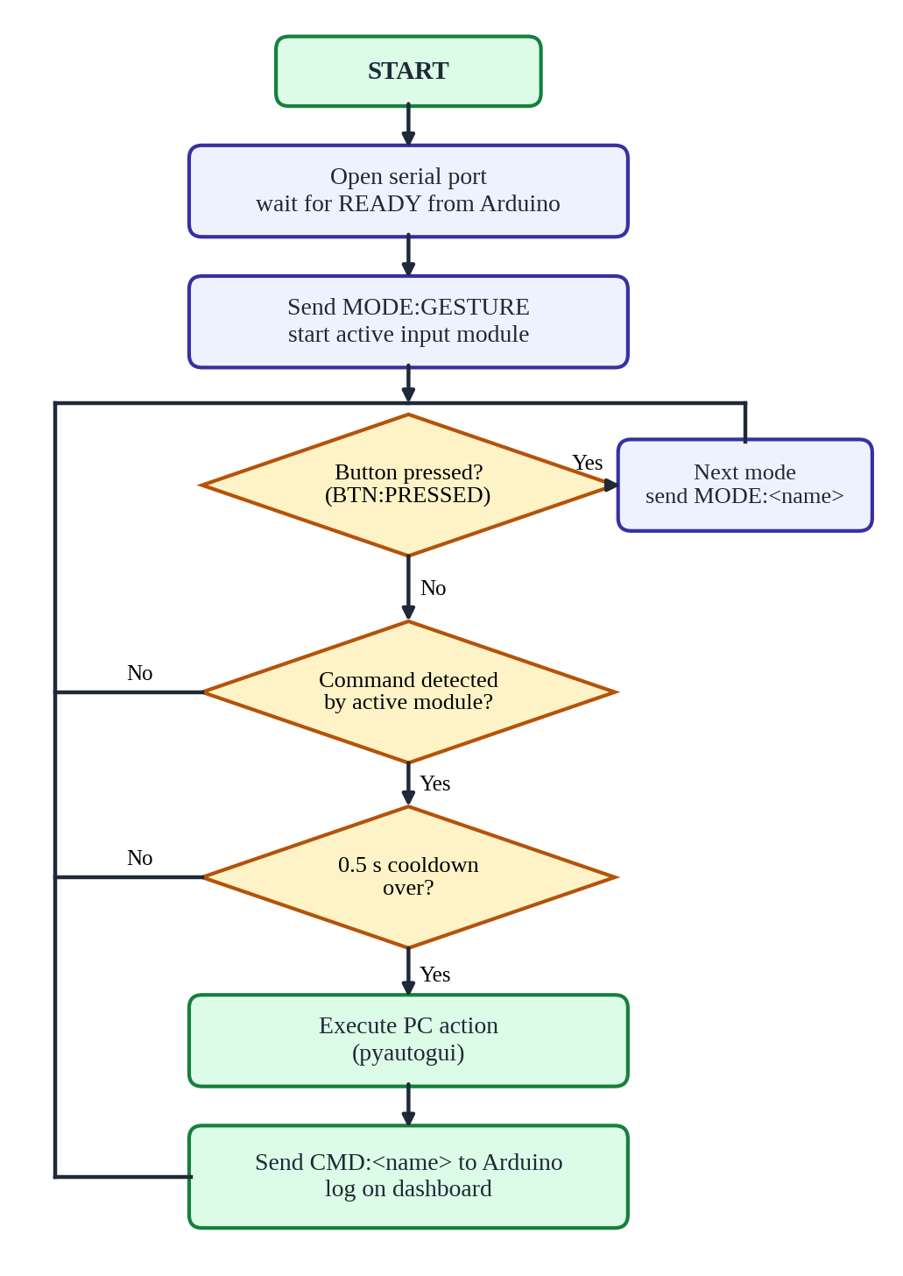
Figure 5.1: Flowchart of the main controller

5.8 Step 7: Flask Dashboard
A small Flask server runs next to the controller. It returns the latest commands as JSON for the web page and accepts a mode change from the browser. The code below is a simplified outline.
from flask import Flask, jsonify
app = Flask(__name__)
log, state = [], {"mode": "GESTURE"}

@app.route("/api/log")
def get_log():
return jsonify(state=state, log=log[-20:])

@app.route("/api/mode/<name>", methods=["POST"])
def set_mode(name):
state["mode"] = name.upper() # controller then sends MODE:<name>
return jsonify(state)

app.run(port=5000)

5.9 Step 8: Testing and Tuning
Table 5.1: Test plan
No. | Test | Expected result
1 | Python sends MODE:GESTURE | Blue LED on; LCD line 1 shows MODE: GESTURE
2 | Press the button once | Python receives exactly one BTN:PRESSED (no bounce repeats)
3 | Press the button three times | Mode cycles Gesture, Voice, Face, Gesture; LED and LCD follow
4 | Show a gesture and hold it | One command is printed, not a flood of repeats
5 | Say “open chrome” | Chrome opens; LCD shows Last: OPEN_CHROME
6 | Blink in face mode | CLICK is performed and shown on the LCD
7 | Disconnect the camera or microphone | ERR:NO_CAM or ERR:NO_MIC is sent; red LED turns on
8 | Use the dashboard | New commands appear in the log; mode toggle changes the LEDs
9 | Open the Serial Monitor and run Python | Python reports that the port is busy; closing the monitor fixes it

During tuning, the following were adjusted: lighting and camera position for hand and face detection, microphone distance and background noise for voice, and the cooldown time and hold time to avoid false triggers. After all tests passed, the features were frozen, the report was written, a backup demo video was recorded and the team practised for the demonstration and viva.

5.10 Common Problems and Solutions
Table 5.2: Troubleshooting
Problem | Likely cause | Solution
Upload fails or port not listed | Wrong COM port or missing driver | Check Device Manager; select the Arduino port (COM6 here, not COM3)
LCD is blank | Wrong I2C address or contrast too low | Try 0x3F; turn the contrast potentiometer on the backpack
LED does not light | LED reversed or resistor loose | Long leg towards the Arduino pin; recheck the row
Python cannot open the port | Serial Monitor or another program is using it | Close the Serial Monitor and other programs
Gesture or face not detected | Poor lighting | Face a light source; avoid strong backlight
Voice not recognised | Noise or distance from microphone | Speak clearly close to the microphone; reduce noise

6. MODEL IMAGES
The photographs and screenshots of the working model are shown below.
Insert photo here | Insert photo here
Figure 6.1: Arduino control panel on the breadboard | Figure 6.2: LCD showing mode and last command
Insert photo here | Insert photo here
Figure 6.3: Gesture mode (blue LED) | Figure 6.4: Voice mode (green LED)
Insert photo here | Insert photo here
Figure 6.5: Face mode (yellow LED) | Figure 6.6: Flask dashboard with command log

7. CONCLUSION

7.1 Conclusion
TriSense shows that a PC can be controlled without touching it by combining hand gestures, voice commands and face/head movement, and that a low-cost Arduino Uno can turn this software into a clear, tangible interface. The Arduino panel lets the user change mode with one button, and the LEDs and LCD show at a glance which mode is active and which command was executed. The strict message contract, the cooldown rule and the module-by-module testing made it possible for several people to build the parts separately and join them without conflicts.

7.2 Learning Outcomes
- Interfacing digital inputs and outputs with a microcontroller, including pull-up resistors and button debouncing.
- Using the I2C protocol to drive an LCD with two wires.
- Serial (UART) communication between a microcontroller and a PC using a simple text protocol.
- Using OpenCV, MediaPipe and Vosk for real-time gesture, face and voice recognition.
- Planning, testing and integrating a project as a team.

7.3 Future Scope
- More gestures and user-defined (custom) commands that the user can train.
- Wireless connection (Bluetooth or Wi-Fi, for example HC-05 or ESP32) instead of the USB cable.
- Multi-language and more noise-robust voice commands.
- Eye-gaze cursor control and smoother head tracking.
- A mobile-app dashboard and control of several devices.

7.4 References
- Arduino documentation: https://docs.arduino.cc
- Microchip, ATmega328P datasheet: https://www.microchip.com
- MediaPipe solutions guide: https://developers.google.com/mediapipe
- OpenCV documentation: https://docs.opencv.org
- Vosk offline speech recognition: https://alphacephei.com/vosk
- PyAutoGUI documentation: https://pyautogui.readthedocs.io
- Flask documentation: https://flask.palletsprojects.com
- pySerial documentation: https://pyserial.readthedocs.io

